Proximity Switch: QC Guide

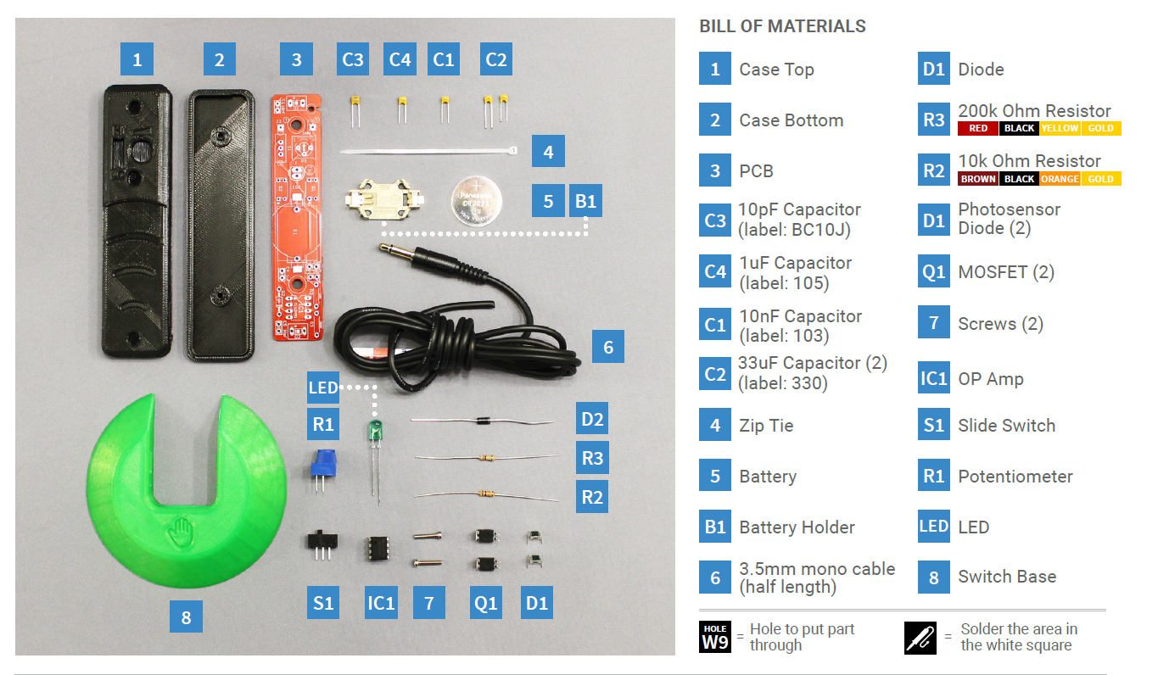

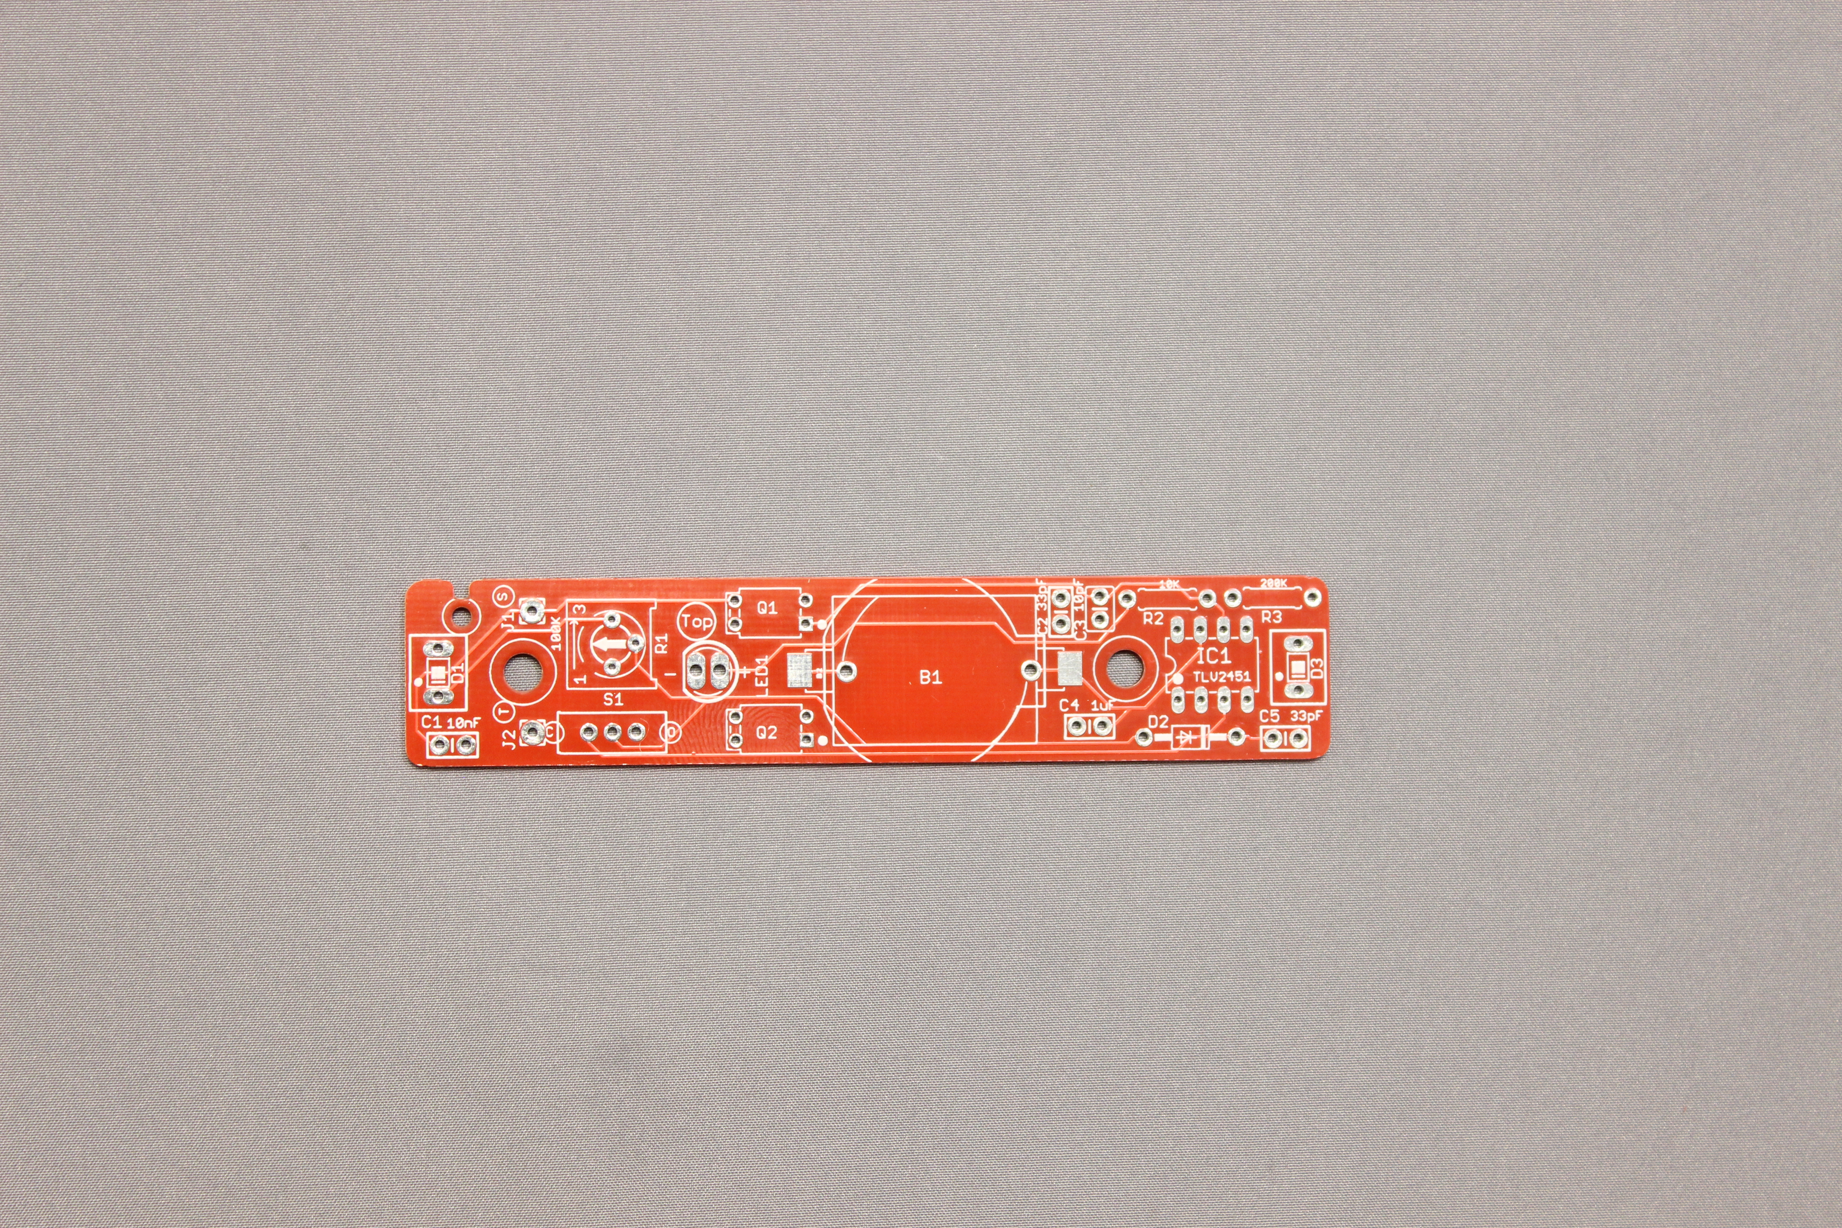 | Solder on the correct PCB side  All component will be inserted on the PCB side that says “Top” and soldered on the side marked “Bottom”.
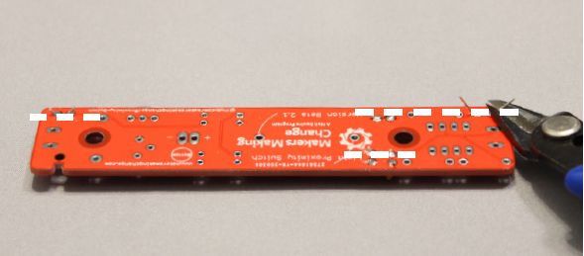 | Trim all excess leads  There is limited space between the bottom of the PCB and the bottom case. Make sure all leads are trimmed after soldering so it fits in the case.
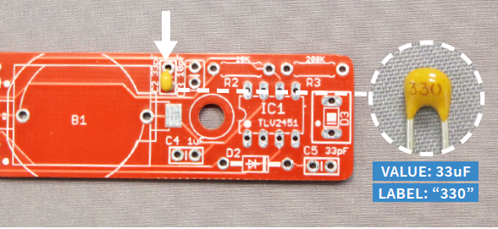 | Capacitors  Capacitors may look similar so look at the printed labelling to differentiate them.
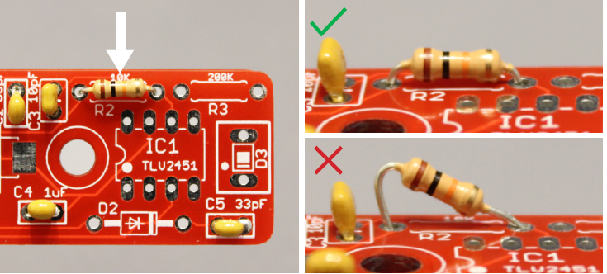 | Ensure components are inserted flush to the board  Components not soldered flush to the board may interfere with the case. A good tip is to solder one lead first, check to see if part is flush, and continue soldering.
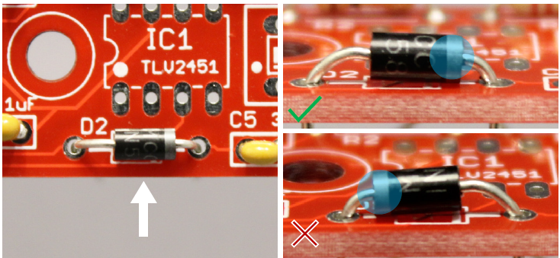 | Diode  Insert the diode with the silver band towards the C5 marking.
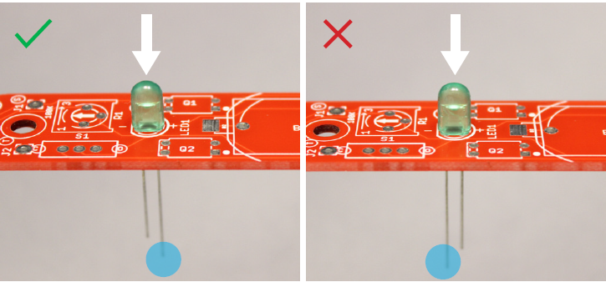 | LED  Insert the LED with the longer lead towards the centre of the PCB.
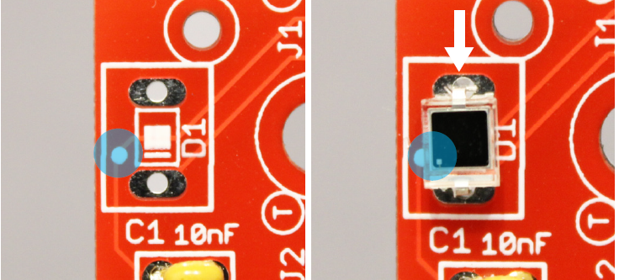 | White dot  Several components have white dots on the top. Align the white dot on the component with the white dot on the PCB.
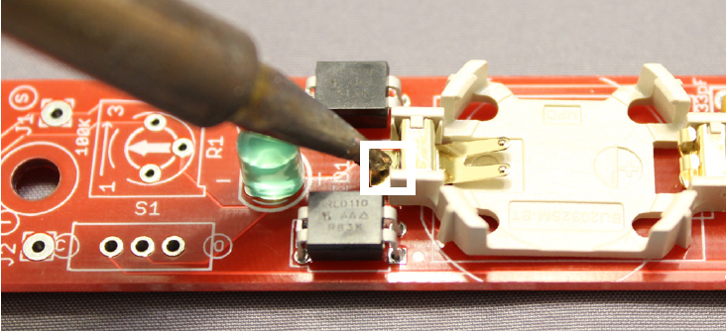 | Soldering the battery holder  Be careful of the soldering iron when soldering the battery holder to the PCB as the heat may damage surrounding components.
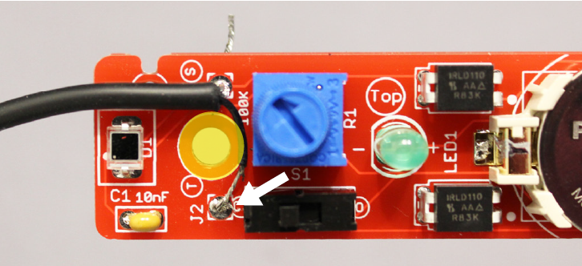 | Mono cable  When inserting and soldering the mono cable to the PCB, ensure enough clearance around the highlighted yellow circle.
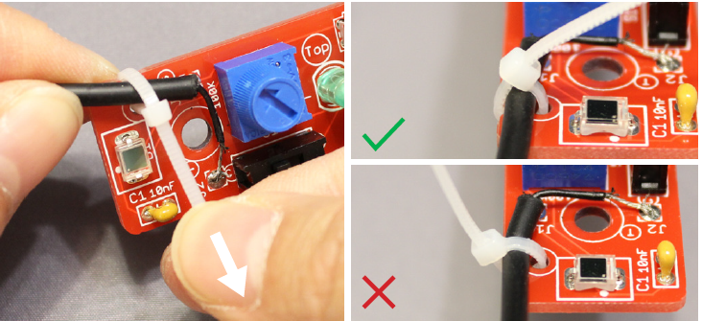 | Zip tie  Cinch the zip tie in the depicted manner or else the knot will interfere with the case.
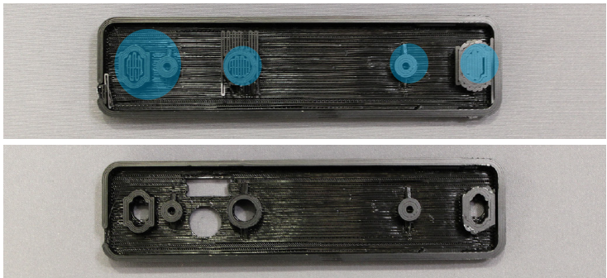 | Support Material  Remove all the support material from the top case.

